Local publication for call for proposals
EUPA4BiH - European Union Police Assistance for Bosnia and Herzegovina  Publication reference: EuropeAid/173156/DD/ACT/BA | 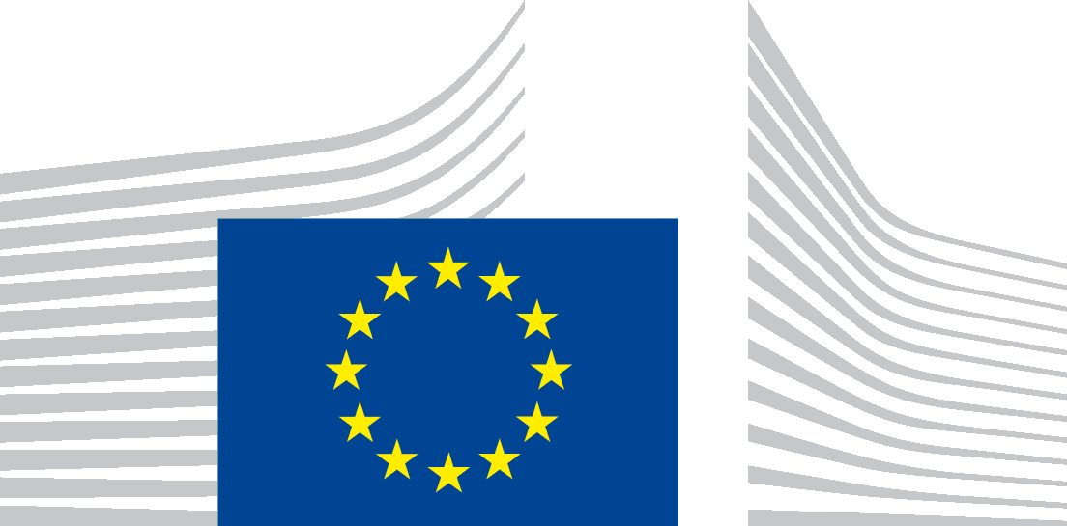
The Delegation of the European Union to Bosnia and Herzegovina (BiH) is seeking proposals for the Call in subject under the financial assistance from the Instrument for Pre-Accession (IPA II).
The specific objectives of this call for proposals are:
- To enhance the effectiveness of institutions involved in the fight against transnational organised crime, corruption, drugs, money laundering, cybercrime, trafficking of human beings, terrorism, radicalisation, violent extremism, corruption and ensure better institutional interoperability,
- To further improve the collection and data exchange, and data protection according to the EU applicable standards and best practices,
- To improve governance standards, to embed stability and progress towards EU membership, better identify and respond to threats, and strengthen capacities to prevent and fight crimes.
The full guidelines for applicants are available for consultation on the following internet site: https://webgate.ec.europa.eu/europeaid/online-services/index.cfm?do=publi.welcome.
The deadline for submission of proposals is 1st February 2022 at 12:00 (time zone of Bosnia and Herzegovina).
An information session on this call for proposals will be held online on 19th November 2021 at 11:00. The conditions to participate to the information session are indicated in the guidelines for applicants.

